CEE 532 – Developing Software Engineering Applications

Project 2 – Truss Analysis

*Michael Justice*

11/05/15

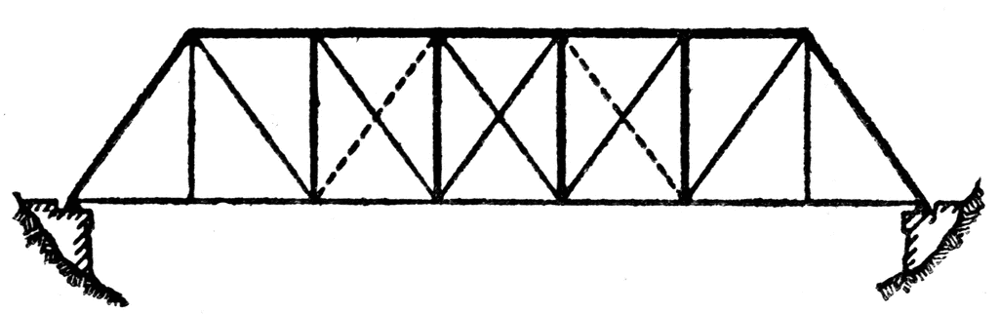

Table of Contents

Introduction 3

An Overview of The Direct Stiffness Method 3

Response due to Prescribed Nodal Displacements 4

Response due to Nodal Temperature Changes 5

The Support Reactions 5

The 3D Implementation 6

Miscellaneous: Absolute Error and Relative Error 6

Planar Truss Test Cases 7

Space Truss Test Cases 15

# Introduction

Creating a truss analysis program for this course consisted of taking a limited planar truss analysis program and modifying the program to compute the necessary response of the system associated with nodal applied loads, initial nodal displacements and nodal temperature changes. The response data consisted of element strain, stress, and force, in addition to the computation of nodal displacements and the support reactions. In order to compute the required responses of the system, the Direct Stiffness Method (DSM, a popular finite element method) was used. The addition of 3-dimensional analysis for the truss analysis program was also implemented.

# An Overview of The Direct Stiffness Method

In order to compute the response data of the system, the direct stiffness method was utilized. Essentially, the DSM is used to solve for the displacements of the system first, and then the strains and consequential forces in the elements are then computed. The primary equation that is used several times, in many forms, is in relation to Hooke’s Law, which states that an element (or spring) of a certain stiffness, is proportional to the force applied. In short, there is a linear relationship between force and displacement, and that relationship is the stiffness of the element. The relationship in mathematical form is shown below.

$$K_{DOFxDOF}D_{DOFx1}=F_{nx1}$$

where K is the assembled global stiffness matrix of the system, D is the global displacements, and F is the global applied forces. There is a distinction between what is considered global and what is considered local. Local describes that of a single element of the truss, whereas global describes the condition of the system in its entirety (all elements). For every element, we are solving an equation to determine the displacements at every degree-of-freedom (DOF) for that element. Therefore, the size of these matrices is of the DOF *of the system*. The local stiffness, displacements and forces are comprised of the following equation,

$${k'}_{2x2}{d'}_{2x1}={f'}_{2x1}$$

Note the difference in size! The local stiffness matrix is only a 2x2. This is because the local system is only of the forces and displacements that happen at *a single element*. Since this is a truss, we only have axial and longitudinal forces and displacements, respectively (unlike frames, for example). Therefore, we can write the equation as shown above since there is one force and displacement at *each node* of the element. Considering that two nodes make up an element, the size of 2 comes about. In order to create a stiffness matrix for an element that is suitable on the global scale (which is wanted, since we are concerned about how each element within the system responds to each other), we must *transform* the matrix using some geometry and matrix algebra. The transformation matrix is a matrix that contains the directional cosines of the element. This is useful since the truss elements can be oriented in any direction. The transformation matrix is shown below.

$$T_{2x6}=\left[\begin{matrix}l & m \\ 0 & 0\end{matrix} \begin{matrix}n & 0 \\ 0 & l\end{matrix} \begin{matrix}0 & 0 \\ m & n\end{matrix}\right]$$

Note that the above matrix is for the 3-dimensional truss. The matrix is of a size 2x6, since there are effectively 6 degrees-of-freedom at each element (3 at each node). For a 2D truss, the size would be a 2x4 (only x-y, or planar orientation possible). The $l, m$ and $n$ variables correspond to the directional cosines of the element. The $l$ is along the x-direction, the $m$ along the y-direction, and the $n$ along the z-direction. Again, if this were 2D, only $l$ and $m$ would be present in the transformation matrix. Using some algrebraic manipulation (and a little theory), we can form the global stiffness matrix for each element as shown below (using 3D as an example),

$$k_{6x6}=T_{6x2}^{T}{k'}_{2x2}T_{2x6}$$

Where $k$ is the global stiffness matrix for a single element. As can be seen, the global stiffness matrix for a single element is a square matrix with a size equal to the DOF of the element. We can assemble all the global stiffness matrices of each element to create the assembled global stiffness matrix $K$**.** We cannot solve the equations until the boundary conditions are imposed. Essentially, equations that correlate to displacements of zero (fixed boundary condition) are removed from the stiffness matrix. The result is a system of equations that include only the displacements corresponding to the nodes with free boundary conditions. With this assembled, boundary-imposed stiffness matrix, we can now solve for the displacements at each free boundary condition of the truss due to the applied forces through use of Cholesky Decomposition, or LDLT factorization (see Project 1 – A Matrix Toolbox for a more detailed description and algorithm). With the displacements now known, the strains can be computed using fundamental engineering strain calculations and subsequently, the stress and force in the element can be determined from the prescribed elastic modulus and cross-sectional area.

In order to determine the response of the truss system due to applied nodal loads, the global force vector $F$ simply has to be populated to include the applied loads at the applied nodes. The displacements that are determined from solving the assembled equation are purely due to the nodal loads.

# Response due to Prescribed Nodal Displacements

If we prescribe a fixed node to have an initial displacement in either direction, the applied loads will be altered based on the prescribed displacement. In turn, the stiffness matrix will then be modified so that the row/column of the prescribed displacement is ‘zeroed out’. Then, the stiffness element corresponding to the prescribed displacement is set to 1. Therefore, this essentially creates the condition that the prescribed displacement variable is equal to the value that is prescribed. This procedure is known as the Elimination Approach. The below matrix is of a set of three equations with the elimination approach applied ( $D_{2}$ is prescribed as $c$),

$$\left[\begin{matrix}K_{11} & 0 & K_{13} \\ 0 & 1 & 0 \\ K_{31} & 0 & K_{33}\end{matrix}\right]\left\{\begin{matrix}D_{1} \\ D_{2} \\ D_{3}\end{matrix}\right\}=\left\{\begin{matrix}F_{1}-K_{12}c \\ c \\ F_{3}-K_{32}c\end{matrix}\right\}$$

After the elimination approach has been utilized, the displacements can be solved as before.

# Response due to Nodal Temperature Changes

If an element undergoes temperature changes, the element will either expand or contract according to the laws of thermal expansion. The strain developed to cause such changes in length is shown below.

$$ϵ_{t,n}=αΔT$$

Where $ϵ_{t,n}$ is the strain due to thermal effects, $α$ is the coefficient of thermal expansion (CTE) and $ΔT$ is the temperature change. For this analysis, temperature changes are prescribed initially at the nodes, not the elements. Taking the average of the node temperature changes between two nodes that join an element, the strain in the element due to thermal effects is thus,

$$ϵ_{t,ele}=α*(\frac{{ΔT}_{SN}+{ΔT}_{EN}}{2})$$

Where SN denotes the start node and EN denotes the end node. This assumption is quite a radical one, as we are assuming that the temperature changes linearly across the length of the element. A more accurate model should be used here to collect the temperature changes across the elements, but the average method will be used moving forward.

Once the strains are calculated, the thermal loads can be computed using the below equation.

$${({q^{'}}_{t})}_{2x1}=EAϵ_{t,ele}\left\{\begin{matrix}-1 \\ 1\end{matrix}\right\} and q_{t}=T^{T}{q^{'}}_{t}$$

We must note here that the thermal load vector, ${q^{'}}_{t}$ must be transformed into its global counterpart so that it can be added to the global load vector. Once the displacements are determined as per the usual procedure, the thermal strains must be removed from the computed strains. Moving forward with the known strains, the element stresses and forces can be determined.

# The Support Reactions

The reactions at the supports of the truss system can be determined by formulating a reactions vector based on the elemental member forces. The reactions vector is populated over each elemental member force vector to produce a vector that contains the reactions at the fixed locations. The equation is shown below.

$$R=R+AT^{T}f'$$

Where $R$ is the reactions vector the size of the number of known fixed locations and $A$ is a binary matrix that selects the appropriate force from the force vector (the forces that are at the fixed locations). The reactions vector is summed over all the elements.

# The 3D Implementation

The implementation of 2-dimensions to 3-dimensions for truss analysis is quite simple. In essence, the matrices used and the procedure to determine the response remains identical to that of the planar truss, yet the size of particular matrices are larger due to the added dimension. The labeling schemes for the nodes and associated displacements are slightly different, as well. However, the process to compute the response of the system remains the same and therefore, not much else will be stated here.

# Miscellaneous: Absolute Error and Relative Error

We were also tasked to determine the absolute and relative error norms of the residual vector from Cholesky Decomposition. The theory and algorithm will not be mentioned here in full detail (see Project 1 for more information). Essentially, these values are an indication of the accuracy of the solution. The absolute and relative error norms are shown below.

$$Absolute error= \left\|r\right\|$$

$$Relative error= \frac{\left\|r\right\|}{\left\|b\right\|}$$

Where $r$ is the residual vector resulting from $KD-F$ and $b$ is the nodal load vector. These normalized values are determined by taking the ‘two-norm’ of the vectors (see Project 1).

# Planar Truss Test Cases

In order to ensure that the response data generated from the truss analysis is accurate, several test cases were run and compared with a proven finite element program (GS-USA). The planar truss test cases are as follows, with the model shown first below.

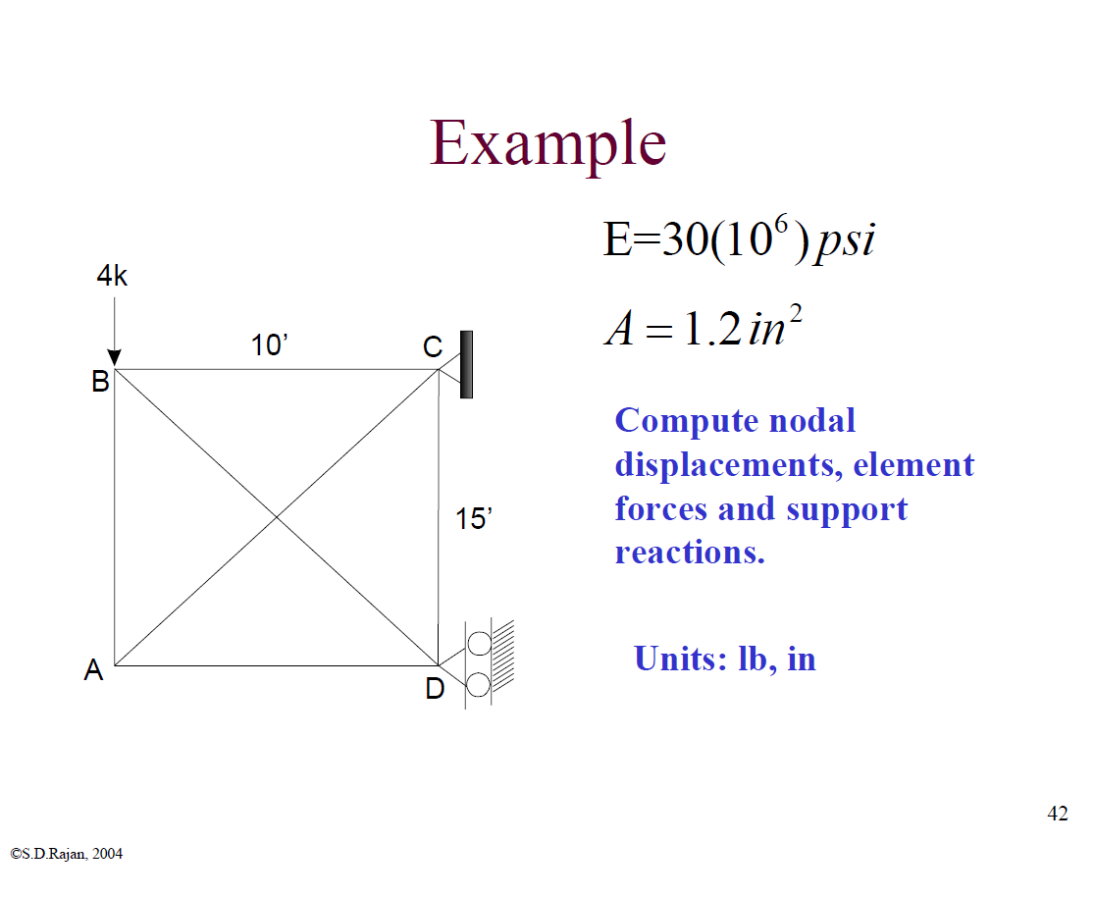

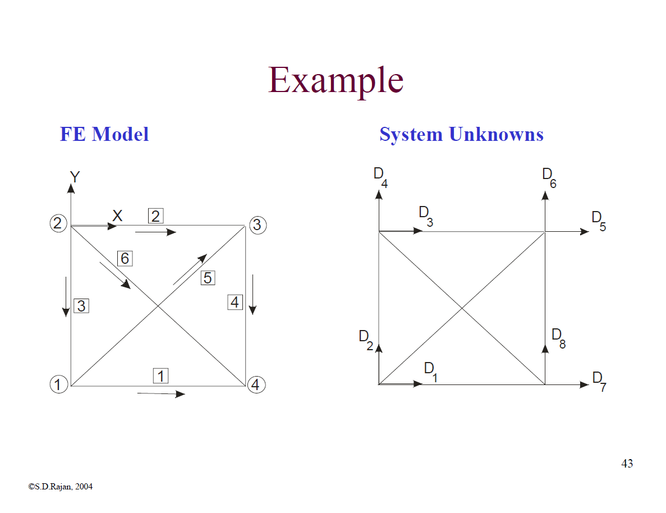

Analyzing this truss with the given conditions below, the elemental force values were compared with that of the values computed from GS-USA. Note that the units are pounds, inches and Fahrenheit.

|  |  |  |
| --- | --- | --- |
| Table 1: Planar Truss Test Case 1 | | |
| **Elemental Forces (lbs)** |  |  |
| ***Conditions*** | ***Source*** | |
| *4000 lbs (-Y-dir.) at node 2.* | *My Truss* | *GS-USA* |
| Element 1 | $1333.33$ (C) | $1333.33$ (C) |
| Element 2 | $1333.33$ (T) | $1333.33$ (T) |
| Element 3 | $2000$ (C) | $2000$ (C) |
| Element 4 | $2000$ (T) | $2000$ (T) |
| Element 5 | $2403.7$ (T) | $2403.7$ (T) |
| Element 6 | $2403.7$ (C) | $2403.7$ (C) |
| Reactions at fixed nodes: | Node 3: X: 2666.67  Y: 4000  Z: 0 | Node 3: X: 2666.67  Y: 4000  Z: 0 |
| ***Absolute Error Norm:***  1.64355e-012  ***Relative Error Norm:***  4.10888e-016 | Node 4: X: -2666.67  Y: 0  Z: 0 | Node 4: X: -2666.67  Y: 0  Z: 0 |

The output file is as shown below.

Output File

--------------------------------------------

Space Truss Analysis Program

Introduction to Structural Analysis & Design

(c) 2000-15, S. D. Rajan

Enhanced By: Michael Justice

--------------------------------------------

PROBLEM SIZE

------------

Number of nodes : 4

Number of elements : 6

Number of DOF : 5

NODAL COORDINATES

-----------------

Node X-Coordinate Y-Coordinate Z-Coordinate

---- ------------ ------------ ------------

1 0 0 0

2 0 180 0

3 120 180 0

4 120 0 0

NODAL FIXITIES

--------------

Node X-Fixity X-Disp Y-Fixity Y-Disp Z-Fixity Z-Disp

---- ------- ------- ------- ------- ------- -------

1 Free Free Known 0

2 Free Free Known 0

3 Known 0 Known 0 Known 0

4 Known 0 Free Known 0

NODAL FORCES

------------

Node X-Force Y-Force Z-Force Delta T

---- ------- ------- ------- -------

2 0 -4000 0 0

ELEMENT DATA

----------------

Element SN EN Area Modulus CTE

------- ----- ----- ----- ------- -----

1 1 4 1.2 3e+007 1.2e-005

2 2 3 1.2 3e+007 1.2e-005

3 2 1 1.2 3e+007 1.2e-005

4 3 4 1.2 3e+007 1.2e-005

5 1 3 1.2 3e+007 1.2e-005

6 2 4 1.2 3e+007 1.2e-005

====================== FE RESULTS ======================

NODAL DISPLACEMENTS

-------------------

Node X-Displacement Y-Displacement Z-Displacement

---- -------------- -------------- --------------

1 0.00444444 -0.020323 0

2 -0.00444444 -0.030323 0

3 0 0 0

4 0 -0.01 0

ELEMENT RESPONSE (Tension is positive)

----------------

Element Strain Stress Force

------- ------ ------ -----

1 -3.7037e-005 -1111.11 -1333.33

2 3.7037e-005 1111.11 1333.33

3 -5.55556e-005 -1666.67 -2000

4 5.55556e-005 1666.67 2000

5 6.67695e-005 2003.08 2403.7

6 -6.67695e-005 -2003.08 -2403.7

NODAL REACTIONS

---------------

Node X-Reaction Y-Reaction Z-Reaction

---- --------- --------- ---------

1 -0

2 -0

3 2666.67 4000 -0

4 -2666.67 -0

Absolute Error Norm: 1.64355e-012

Relative Error Norm: 4.10888e-016

The same truss was analyzed, but with an initial displacement along the y-direction at node 4. The table comparing the results is shown below, along with the output file.

|  |  |  |
| --- | --- | --- |
| Table 2: Planar Truss Test Case 2 | | |
| Elemental Forces (lbs) |  |  |
| ***Conditions*** | ***Source*** | |
| *4000 lbs (-Y-dir.) at node 2, -0.1 in y-disp. at node 4.* | *My Truss* | *GS-USA* |
| Element 1 | $3702.72$ (C) | $3702.72$ (C) |
| Element 2 | $1036.05$ (C) | $1036.05$ (C) |
| Element 3 | $5554.08$ (C) | $5554.08$ (C) |
| Element 4 | $20000$ (T) | $20000$ (T) |
| Element 5 | $6675.17$ (T) | $6675.17$ (T) |
| Element 6 | $1867.77$ (T) | $1867.77$ (T) |
| Reactions at fixed nodes: | Node 3: X: 2666.67  Y: 25554.1  Z: 0 | Node 3: X: 2666.67  Y: 25554.1  Z: 0 |
| ***Absolute Error Norm:***  4.16783e-012  ***Relative Error Norm:***  2.40677e-016 | Node 4: X: -2666.67  Y: -21554.1  Z: 0 | Node 4: X: -2666.67  Y: -21554.1  Z: 0 |

Output File

--------------------------------------------

Space Truss Analysis Program

Introduction to Structural Analysis & Design

(c) 2000-15, S. D. Rajan

Enhanced By: Michael Justice

--------------------------------------------

PROBLEM SIZE

------------

Number of nodes : 4

Number of elements : 6

Number of DOF : 4

NODAL COORDINATES

-----------------

Node X-Coordinate Y-Coordinate Z-Coordinate

---- ------------ ------------ ------------

1 0 0 0

2 0 180 0

3 120 180 0

4 120 0 0

NODAL FIXITIES

--------------

Node X-Fixity X-Disp Y-Fixity Y-Disp Z-Fixity Z-Disp

---- ------- ------- ------- ------- ------- -------

1 Free Free Known 0

2 Free Free Known 0

3 Known 0 Known 0 Known 0

4 Known 0 Known -0.1 Known 0

NODAL FORCES

------------

Node X-Force Y-Force Z-Force Delta T

---- ------- ------- ------- -------

2 0 -4000 0 0

ELEMENT DATA

----------------

Element SN EN Area Modulus CTE

------- ----- ----- ----- ------- -----

1 1 4 1.2 3e+007 1.2e-005

2 2 3 1.2 3e+007 1.2e-005

3 2 1 1.2 3e+007 1.2e-005

4 3 4 1.2 3e+007 1.2e-005

5 1 3 1.2 3e+007 1.2e-005

6 2 4 1.2 3e+007 1.2e-005

====================== FE RESULTS ======================

NODAL DISPLACEMENTS

-------------------

Node X-Displacement Y-Displacement Z-Displacement

---- -------------- -------------- --------------

1 0.0123424 -0.0564378 0

2 0.00345351 -0.0842082 0

3 0 0 0

4 0 -0.1 0

ELEMENT RESPONSE (Tension is positive)

----------------

Element Strain Stress Force

------- ------ ------ -----

1 -0.000102853 -3085.6 -3702.72

2 -2.87792e-005 -863.376 -1036.05

3 -0.00015428 -4628.4 -5554.08

4 0.000555556 16666.7 20000

5 0.000185421 5562.64 6675.17

6 5.18825e-005 1556.47 1867.77

NODAL REACTIONS

---------------

Node X-Reaction Y-Reaction Z-Reaction

---- --------- --------- ---------

1 -0

2 -0

3 2666.67 25554.1 -0

4 -2666.67 -21554.1 -0

Absolute Error Norm: 4.16783e-012

Relative Error Norm: 2.40677e-016

Again, but with the addition of temperature changes at the elements that connect to node 4. The table below contains the results.

|  |  |  |
| --- | --- | --- |
| Table 3: Planar Truss Test Case 3 |  |  |
| *Elemental Forces (lbs)* |  |  |
| ***Conditions*** | ***Source*** | |
| *4000 lbs (-Y-dir.) at node 2, -0.1 in y-disp. at node 4, 50 temp. change at node 3.* | *My Truss* | *GS-USA* |
| Element 1 | $$2281.09 (C)$$ | $$2281.09 (C)$$ |
| Element 2 | $$385.58 (T)$$ | $$385.58 (T)$$ |
| Element 3 | $$3421.63 (C)$$ | $$3421.63 (C)$$ |
| Element 4 | $$9200 (T)$$ | $$9200 (T)$$ |
| Element 5 | $$4112.29 (T)$$ | $$4112.29 (T)$$ |
| Element 6 | $$695.114 (C)$$ | $$695.113 (C)$$ |
| Reactions at fixed nodes: | Node 3: X: 2666.67  Y: 12621.6  Z: 0 | Node 3: X: 2666.67  Y: 12621.6  Z: 0 |
| ***Absolute Error Norm:***  7.33258e-012  ***Relative Error Norm:***  3.8262e-016 | Node 4: X: -2666.67  Y: -8621.63  Z: 0 | Node 4: X: -2666.67  Y: -8621.63  Z: 0 |

Output File

--------------------------------------------

Space Truss Analysis Program

Introduction to Structural Analysis & Design

(c) 2000-15, S. D. Rajan

Enhanced By: Michael Justice

--------------------------------------------

PROBLEM SIZE

------------

Number of nodes : 4

Number of elements : 6

Number of DOF : 4

NODAL COORDINATES

-----------------

Node X-Coordinate Y-Coordinate Z-Coordinate

---- ------------ ------------ ------------

1 0 0 0

2 0 180 0

3 120 180 0

4 120 0 0

NODAL FIXITIES

--------------

Node X-Fixity X-Disp Y-Fixity Y-Disp Z-Fixity Z-Disp

---- ------- ------- ------- ------- ------- -------

1 Free Free Known 0

2 Free Free Known 0

3 Known 0 Known 0 Known 0

4 Known 0 Known -0.1 Known 0

NODAL FORCES

------------

Node X-Force Y-Force Z-Force Delta T

---- ------- ------- ------- -------

2 0 -4000 0 0

3 0 0 0 50

ELEMENT DATA

----------------

Element SN EN Area Modulus CTE

------- ----- ----- ----- ------- -----

1 1 4 1.2 3e+007 1.2e-005

2 2 3 1.2 3e+007 1.2e-005

3 2 1 1.2 3e+007 1.2e-005

4 3 4 1.2 3e+007 1.2e-005

5 1 3 1.2 3e+007 1.2e-005

6 2 4 1.2 3e+007 1.2e-005

====================== FE RESULTS ======================

NODAL DISPLACEMENTS

-------------------

Node X-Displacement Y-Displacement Z-Displacement

---- -------------- -------------- --------------

1 0.00760362 -0.112769 0

2 -0.0372853 -0.129877 0

3 0 0 0

4 0 -0.1 0

ELEMENT RESPONSE (Tension is positive)

----------------

Element Strain Stress Force

------- ------ ------ -----

1 -6.33635e-005 -1900.91 -2281.09

2 1.07106e-005 321.317 385.58

3 -9.50453e-005 -2851.36 -3421.63

4 0.000255556 7666.67 9200

5 0.00011423 3426.91 4112.29

6 -1.93087e-005 -579.261 -695.114

NODAL REACTIONS

---------------

Node X-Reaction Y-Reaction Z-Reaction

---- --------- --------- ---------

1 -0

2 -0

3 2666.67 12621.6 -0

4 -2666.67 -8621.63 -0

Absolute Error Norm: 7.33258e-012

Relative Error Norm: 3.8262e-016

# Space Truss Test Cases

The following model was used to test the 3-dimensional truss. In the same manner as above, the results are displayed below, starting with an applied nodal load at node 1 as shown below. Note that the units are pounds, inches and Fahrenheit.

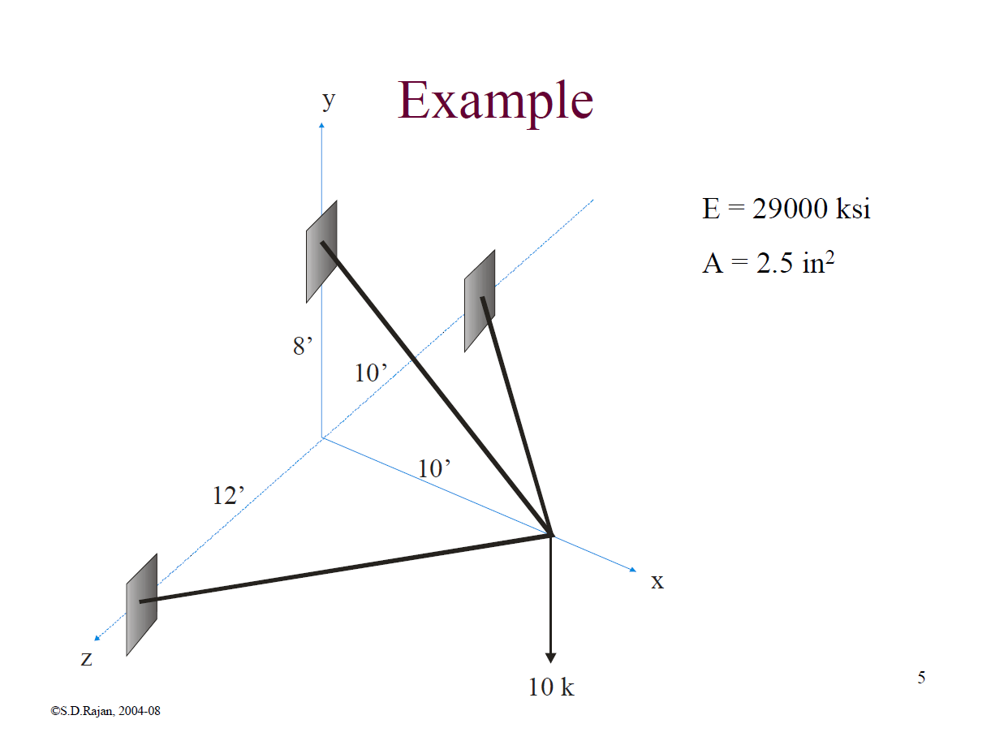

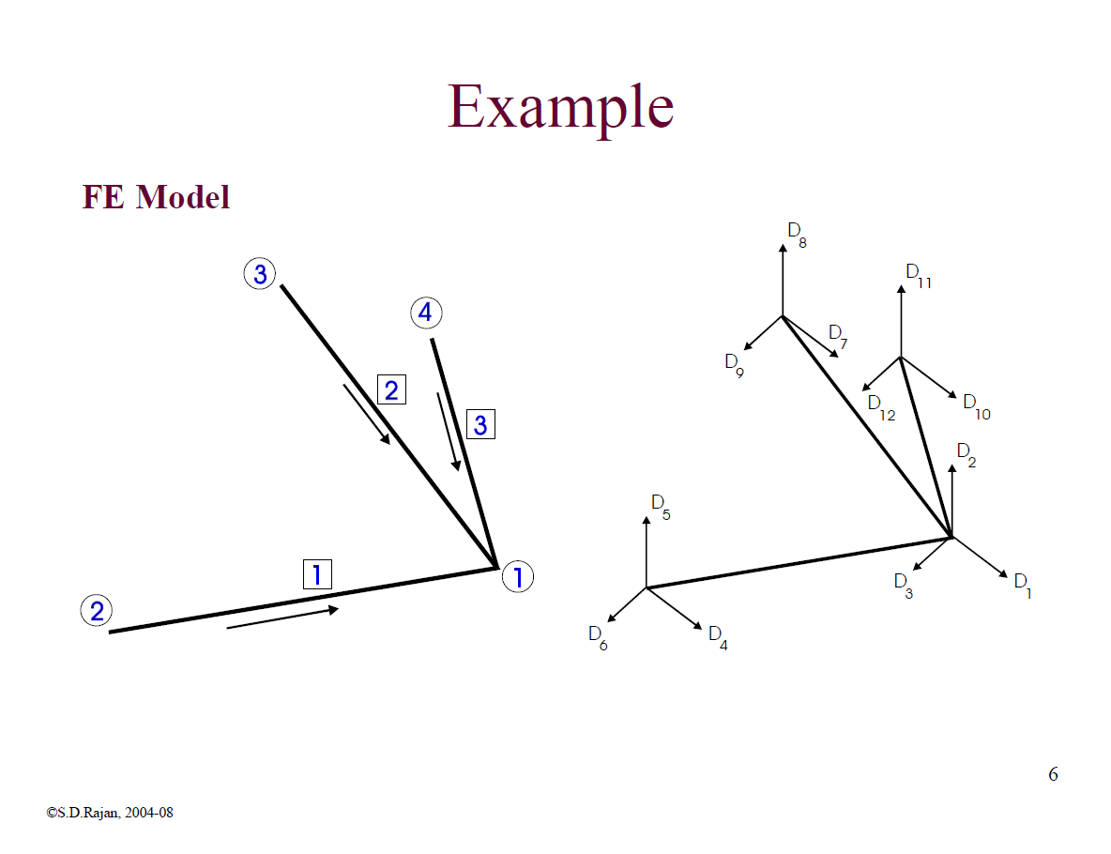

The results for the truss above and the conditions below are shown in the following table. Note the output file that is provided at the end of the table.

|  |  |  |
| --- | --- | --- |
| Table 4 – Space Truss Case 1 | | |
| Elemental Forces (lbs) |  |  |
| ***Conditions*** | ***Source*** | |
| *-10,000 lbs at node 1* | *My Truss* | *From E-Book* |
| Element 1 | 8875.28 (C) | 8875 (C) |
| Element 2 | 16007.8 (T) | 16008 (T) |
| Element 3 | 9642.36 (C) | 9642 (C) |
| Reactions at fixed nodes: | Node 2: X: 5681.82  Y: 0  Z: 6818.18 | Node 2: X: 5681.82  Y: 0  Z: 6818.18 |
| Node 3: X: -12500  Y: 10000  Z: 0 | Node 3: X: -12500  Y: 10000  Z: 0 |
| Node 4: X: 6818.18  Y: 0  Z: -6818.18 | Node 4: X: 6818.18  Y: 0  Z: -6818.18 |
| ***Absolute Error Norm:***  1.82923e-12  ***Relative Error Norm:***  1.82923e-16 |

Output File

--------------------------------------------

Space Truss Analysis Program

Introduction to Structural Analysis & Design

(c) 2000-15, S. D. Rajan

Enhanced By: Michael Justice

--------------------------------------------

PROBLEM SIZE

------------

Number of nodes : 4

Number of elements : 3

Number of DOF : 3

NODAL COORDINATES

-----------------

Node X-Coordinate Y-Coordinate Z-Coordinate

---- ------------ ------------ ------------

1 120 0 0

2 0 0 -144

3 0 96 0

4 0 0 120

NODAL FIXITIES

--------------

Node X-Fixity X-Disp Y-Fixity Y-Disp Z-Fixity Z-Disp

---- ------- ------- ------- ------- ------- -------

1 Free Free Free

2 Known 0 Known 0 Known 0

3 Known 0 Known 0 Known 0

4 Known 0 Known 0 Known 0

NODAL FORCES

------------

Node X-Force Y-Force Z-Force Delta T

---- ------- ------- ------- -------

1 0 -10000 0 0

ELEMENT DATA

----------------

Element SN EN Area Modulus CTE

------- ----- ----- ----- ------- -----

1 2 1 2.5 2.9e+007 1.2e-005

2 3 1 2.5 2.9e+007 1.2e-005

3 4 1 2.5 2.9e+007 1.2e-005

====================== FE RESULTS ======================

NODAL DISPLACEMENTS

-------------------

Node X-Displacement Y-Displacement Z-Displacement

---- -------------- -------------- --------------

1 -0.0337033 -0.0964454 -0.0017838

2 0 0 0

3 0 0 0

4 0 0 0

ELEMENT RESPONSE (Tension is positive)

----------------

Element Strain Stress Force

------- ------ ------ -----

1 -0.000122418 -3550.11 -8875.28

2 0.000220797 6403.12 16007.8

3 -0.000132998 -3856.95 -9642.37

NODAL REACTIONS

---------------

Node X-Reaction Y-Reaction Z-Reaction

---- --------- --------- ---------

1

2 5681.82 -0 6818.18

3 -12500 10000 -0

4 6818.18 -0 -6818.18

Absolute Error Norm: 1.94601e-012

Relative Error Norm: 1.94601e-016

From the table above, we can note that these values are almost exact to the solution in the book. We can also note that if we perform equilibrium checks for the truss, the support reactions provide a very accurate solution. We can readily see this result by observing the absolute and relative error norms. Since the planar truss worked well in comparison to the GS-USA result, It can be assumed that the space truss works equally as well, since only the size of the matrices changed. Provided below are additional outputs from the truss program for different test conditions (note that the following cases were not compared to an exact solution).

|  |  |
| --- | --- |
| Table 5 – Space Truss Case 2 | |
| Elemental Forces (lbs) |  |
| ***Conditions*** | ***Source*** |
| *10,000 lbs (-Y-dir.) at node 1, 500 lbs (-Z dir.) at node 1* | *My Truss* |
| Element 1 | $$8520.27 (C)$$ |
| Element 2 | $$16007.8 (T)$$ |
| Element 3 | $$9963.78 (C)$$ |
| Reactions at fixed nodes: | Node 2: X: 5454.55  Y: 0  Z: 6545.45 |
|  | Node 3: X: -12500  Y: 10000  Z: 0 |
|  | Node 4: X: 7045.45  Y: 0  Z: -7045.45 |
| ***Absolute Error Norm:***  9.00632e-013  ***Relative Error Norm:***  8.99509e-017 |

Output File

--------------------------------------------

Space Truss Analysis Program

Introduction to Structural Analysis & Design

(c) 2000-15, S. D. Rajan

Enhanced By: Michael Justice

--------------------------------------------

PROBLEM SIZE

------------

Number of nodes : 4

Number of elements : 3

Number of DOF : 3

NODAL COORDINATES

-----------------

Node X-Coordinate Y-Coordinate Z-Coordinate

---- ------------ ------------ ------------

1 120 0 0

2 0 0 -144

3 0 96 0

4 0 0 120

NODAL FIXITIES

--------------

Node X-Fixity X-Disp Y-Fixity Y-Disp Z-Fixity Z-Disp

---- ------- ------- ------- ------- ------- -------

1 Free Free Free

2 Known 0 Known 0 Known 0

3 Known 0 Known 0 Known 0

4 Known 0 Known 0 Known 0

NODAL FORCES

------------

Node X-Force Y-Force Z-Force Delta T

---- ------- ------- ------- -------

1 0 -10000 500 0

ELEMENT DATA

----------------

Element SN EN Area Modulus CTE

------- ----- ----- ----- ------- -----

1 2 1 2.5 2.9e+007 1.2e-005

2 3 1 2.5 2.9e+007 1.2e-005

3 4 1 2.5 2.9e+007 1.2e-005

====================== FE RESULTS ======================

NODAL DISPLACEMENTS

-------------------

Node X-Displacement Y-Displacement Z-Displacement

---- -------------- -------------- --------------

1 -0.033632 -0.0963562 -0.000648459

2 0 0 0

3 0 0 0

4 0 0 0

ELEMENT RESPONSE (Tension is positive)

----------------

Element Strain Stress Force

------- ------ ------ -----

1 -0.000117521 -3408.11 -8520.27

2 0.000220797 6403.12 16007.8

3 -0.000137431 -3985.51 -9963.78

NODAL REACTIONS

---------------

Node X-Reaction Y-Reaction Z-Reaction

---- --------- --------- ---------

1

2 5454.55 -0 6545.45

3 -12500 10000 -0

4 7045.45 -0 -7045.45

Absolute Error Norm: 9.00632e-013

Relative Error Norm: 8.99509e-017

From the above table, we can note that the force in element 2 does not change. This is expected since the 500 lb force was applied perpendicularly to element 2. Imposing nodal temp changes, we have,

|  |  |
| --- | --- |
| Table 6 – Space Truss Case 3 | |
| Elemental Forces (lbs) |  |
| ***Conditions*** | ***Source*** |
| *10,000 lbs (-Y dir.) at node 1, 500 lbs (-Z dir.) at node 1, 50 $°$ F temp. change at node 2.* | *My Truss* |
| Element 1 | $$8520.27 (C)$$ |
| Element 2 | $$16007.8 (T)$$ |
| Element 3 | $$9963.78 (C)$$ |
| Reactions at fixed nodes: | Node 2: X: 5454.55  Y: 0  Z: 6545.45 |
|  | Node 3: X: -12500  Y: 10000  Z: 0 |
| ***Absolute Error Norm:***  1.81899e-012  ***Relative Error Norm:***  7.48853e-017 | Node 4: X: 7045.45  Y: 0  Z: -7045.45 |

Output File

--------------------------------------------

Space Truss Analysis Program

Introduction to Structural Analysis & Design

(c) 2000-15, S. D. Rajan

Enhanced By: Michael Justice

--------------------------------------------

PROBLEM SIZE

------------

Number of nodes : 4

Number of elements : 3

Number of DOF : 3

NODAL COORDINATES

-----------------

Node X-Coordinate Y-Coordinate Z-Coordinate

---- ------------ ------------ ------------

1 120 0 0

2 0 0 -144

3 0 96 0

4 0 0 120

NODAL FIXITIES

--------------

Node X-Fixity X-Disp Y-Fixity Y-Disp Z-Fixity Z-Disp

---- ------- ------- ------- ------- ------- -------

1 Free Free Free

2 Known 0 Known 0 Known 0

3 Known 0 Known 0 Known 0

4 Known 0 Known 0 Known 0

NODAL FORCES

------------

Node X-Force Y-Force Z-Force Delta T

---- ------- ------- ------- -------

1 0 -10000 500 0

2 0 0 0 50

ELEMENT DATA

----------------

Element SN EN Area Modulus CTE

------- ----- ----- ----- ------- -----

1 2 1 2.5 2.9e+007 1.2e-005

2 3 1 2.5 2.9e+007 1.2e-005

3 4 1 2.5 2.9e+007 1.2e-005

====================== FE RESULTS ======================

NODAL DISPLACEMENTS

-------------------

Node X-Displacement Y-Displacement Z-Displacement

---- -------------- -------------- --------------

1 0.00629528 -0.0464471 0.0392788

2 0 0 0

3 0 0 0

4 0 0 0

ELEMENT RESPONSE (Tension is positive)

----------------

Element Strain Stress Force

------- ------ ------ -----

1 -0.000117521 -3408.11 -8520.27

2 0.000220797 6403.12 16007.8

3 -0.000137431 -3985.51 -9963.78

NODAL REACTIONS

---------------

Node X-Reaction Y-Reaction Z-Reaction

---- --------- --------- ---------

1

2 5454.55 -0 6545.45

3 -12500 10000 -0

4 7045.45 -0 -7045.45

Absolute Error Norm: 1.81899e-012

Relative Error Norm: 7.48853e-017

As expected, the forces in the elements do not change due to the nodal temp loading at node 2. This is because there is only one free node that can displace according to the thermal loading, and that node is attached to all the elements. Therefore, this node will displace in a new direction according to the thermal loading, but the forces in the elements will remain constant, as they simply move with the free node.